# Write a program to print first 10 even numbers
num=1
c=0
while True:
if num%2==0:
print(num,end=’ ‘)
c=c+1
if c==10:
break
num=num+1

Output
2 4 6 8 10 12 14 16 18 20

Example:
# Write a program to find input number is prime or not

num=int(input("Enter any number "))
c=0

for i in range(1,num+1):
if num%i==0:
c=c+1
if c>2:
break

if c==2:
print(f'{num} is prime')
else:
print(f'{num} is not prime')

Output
Enter any number 6
6 is not prime

Example:
while True:
uname=input("UserName :")
pwd=input("Password :")
if uname=="nit" and pwd=="n123":
print("welcome")
break
print("invalid username or password")

Output
UserName :aaa
Password :bbb
invalid username or password
UserName :bbb
Password :ccc
invalid username or password
UserName :nit
Password :n123
Welcome

Example:
balance=50000
while True:
print("*****ATM******")
print("1.Deposit")
print("2.Withdraw")
print("3.CheckBalance")
print("4.Exit")
opt=int(input("Enter Your Option:"))
if opt==1:
amt=int(input("Amount :"))
balance=balance+amt
print("Transaction Completed")
elif opt==2:
amt=int(input("Amount :"))
if amt<balance:
balance=balance-amt
print("Transaction Completed")
else:
print("Insuff Balance")
elif opt==3:
print(f'Balance {balance}')
elif opt==4:
break
else:
print("Invalid Option Try Again")

Output
*****ATM******
1.Deposit
2.Withdraw
3.CheckBalance
4.Exit
Enter Your Option:3
Balance 45000
*****ATM******
1.Deposit
2.Withdraw
3.CheckBalance
4.Exit
Enter Your Option:2
Amount :80000
Insuff Balance

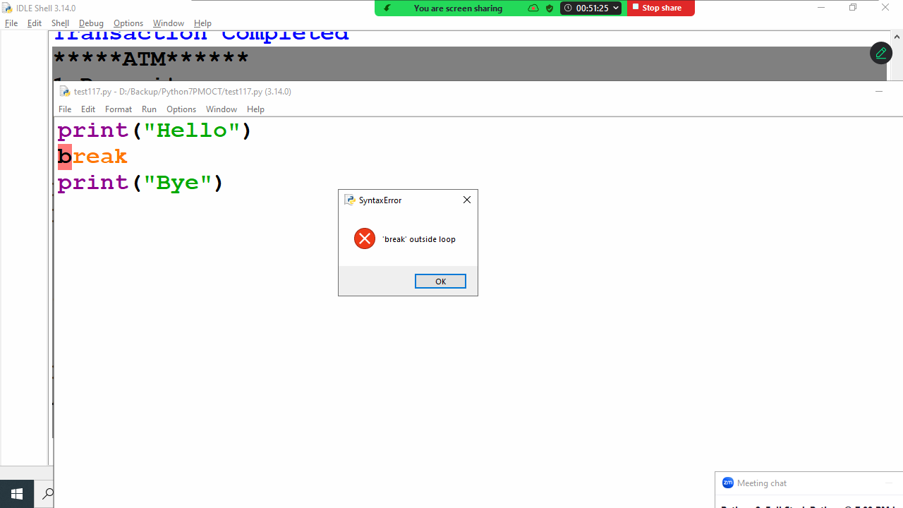

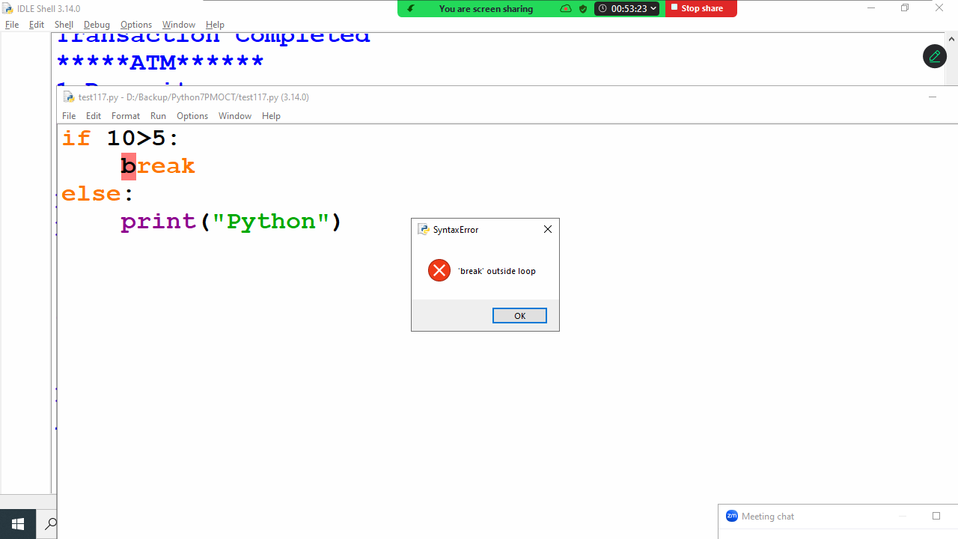
Example:
# write a program to print sum of numbers until sum becomes
# 100, input numbers from keyboard
s=0
while True:
num=int(input("Enter any number "))
s=s+num
if s==100:
break

Output
Enter any number 50
Enter any number 100
Enter any number 200
Enter any number -250

continue
“continue” is a keyword which represents branching control statement.
This statement is used inside looping control statements (while loop and for loop)
continue statement, continue execution of while or for loop without executing the statements written after continue statement.

Example:
for i in range(1,6): # 1 2 3 4 5
print("PYTHON")
break
print("JAVA")

for i in range(1,6): # 1 2 3 4 5
print("PYTHON")
continue
print("JAVA")

Output
PYTHON
PYTHON
PYTHON
PYTHON
PYTHON
PYTHON

Example:
for i in range(1,11):
if i%2==0:
continue
print(i,end=' ')

Output
1 3 5 7 9

pass keyword
python does not allows empty blocks.
A block must have at least one statement.
In python a block with pass statement is called empty block
This block does not perform any operation
Pass indicates null operation or no operation

Example:
if 10>2:
pass
print("PYTHON")

for i in range(5): # 0 1 2 3 4
pass
print("DJANGO")

if 10>2:
pass
else:
print("DATABASE")

Output
PYTHON
DJANGO

Nested Loops
A looping control statement within looping control statement is called nested looping control statement
- Nested while loop
- Nested for loop

While loop inside while loop is called nested while
For loop inside for loop is called nested for

Example:
for num in range(1,11): # 1 2 3 4 5 6 7 8 9 10
for i in range(1,11): # 1 2 3 4 5 6 7 8 9 10
print(f'{num}x{i}={num*i}')

Output
1x1=1
1x2=2
1x3=3
1x4=4
1x5=5
1x6=6
1x7=7
1x8=8
1x9=9
1x10=10
2x1=2
2x2=4
2x3=6
2x4=8
2x5=10
2x6=12
2x7=14
2x8=16
2x9=18
2x10=20

